**Linux Basic Commands Assignment**

**Assignment Part-3**

1. Create a file like nano file1.txt

o Edit some data and then save the file

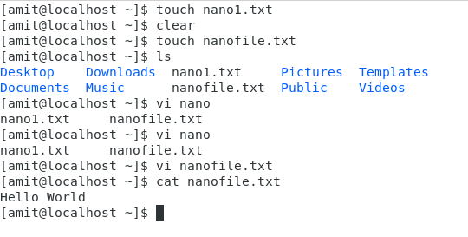

1. Now we will copy date from file1 to new file2 o cp file1.txt file2.txt o Then see the output of file2.txt, cat file2.txt o Give screenshot

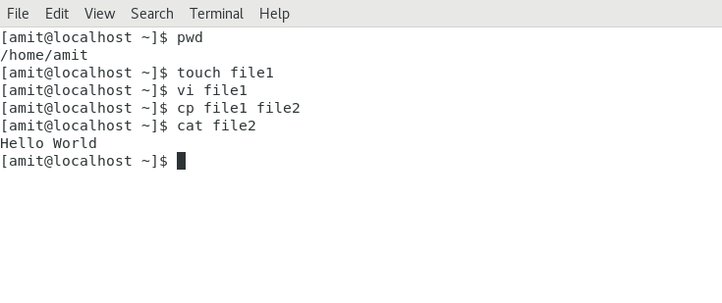

1. Now we will move the file2.txt to new folder /home o mv file2.txt /home o Then go to home directory and check ls, file exits or not? o Given screenshot

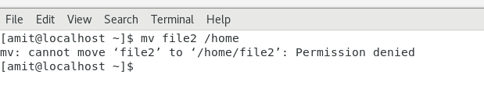

Login as root user and then we can move the file to home directory

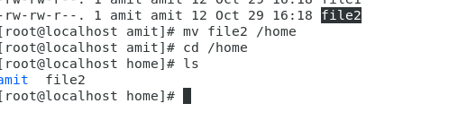

1. Then we create a new file3.txt and file4.txt in home directory and add content in it. o Now do echo “Hello I am newline” > file3.txt and provide the output of file3.txt o Now do echo “Hello I am newline” >> file4.txt and provide the output of file4.txt o Tell the different between both step you follow and the reason behind it

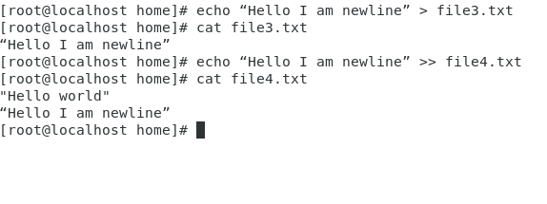

The Difference between the two operator is ‘>’ overwrites the file content whereas ‘>>’ appends the data to existing file

5. For remove a file or directory you can use the below two commands

o To delete a file – rm <any_filename>

nano1 file removed

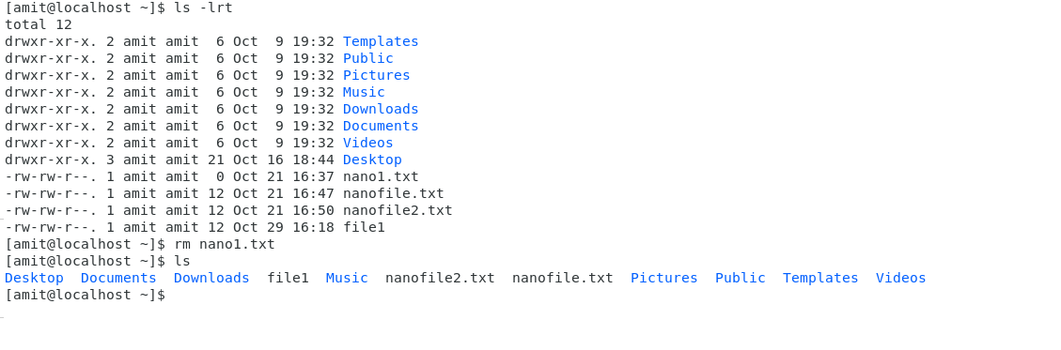

o To delete a directory - rmdir <any_directoryname>

test directory deleted

